Pizza Sales SQL Queries
A.KPI’s
1.Total Revenue:
SELECT cast(SUM (total_price) as decimal(10,2)) AS Total_Revenue FROM pizza_sales
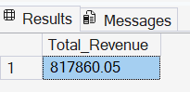
2.Average Order Value
SELECT cast(SUM(total_price)/COUNT(distinct(order_id)) as decimal (10,2)) AS Average_Ordervalue FROM pizza_sales

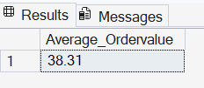
3.Total Pizzas Sold
SELECT sum(quantity) AS Total_Order FROM pizza_sales
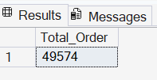
4.Total Orders
select COUNT(distinct(order_id)) AS Total_order FROM pizza_sales
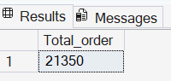
5.Average Pizzas Per Order
select cast(cast(sum(quantity) as decimal(10,2))/cast(COUNT(distinct order_id) as decimal(10,2)) AS decimal(10,2)) as Avrage_sale FROM pizza_sales

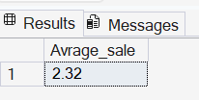
B.Daily Trend For Total Orders
select DATENAME(DW, order_date) AS Order_Day,count(distinct order_id) as Total_orders from pizza_sales GROUP BY DATENAME(DW, order_date)
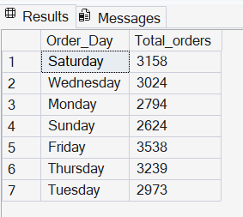
C.Hourly Trend For Orders
select DATEPART(HOUR,ORDER_TIME) AS Order_hours,COUNT(distinct order_id) as TotalOrder FROM pizza_sales GROUP BY DATEPART(HOUR,ORDER_TIME) ORDER BY DATEPART(HOUR,ORDER_TIME)
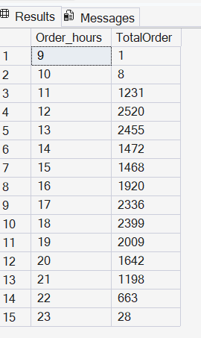
D.% Of Sales by Pizza Category
select pizza_category as CategoryName,CONCAT(cast(sum(total_price)*100/(select sum(total_price) from pizza_sales)as decimal(10,2)),'%') as PCT from pizza_sales group by pizza_category
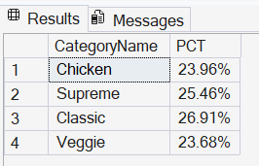
E.% of sales by pizza size
select pizza_size as Pizza_size,CONCAT(cast(sum(total_price)*100/(select sum(total_price) from pizza_sales)as decimal(10,2)),'%') as PCT from pizza_sales group by pizza_size order by PCT DESC
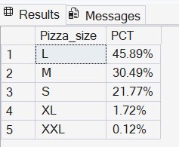
F.Total Pizzas Sold by pizza category
select pizza_category,sum(quantity) as SoldQuantity from pizza_sales group by pizza_category
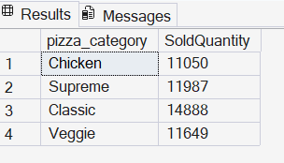
G.Top 5 best sellers by Total Pizzas sold
SELECT top 5 pizza_name as PizzaName,SUM(quantity)as Total_Sold FROM pizza_sales
group by pizza_name order by Total_Sold desc
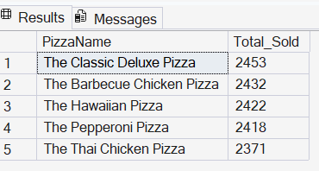
H.Bottom 5 best sellers by total pizzas sold
SELECT top 5 pizza_name as PizzaName,SUM(quantity)as Total_Sold FROM pizza_sales group by pizza_name order by Total_Sold
